Kundu Naturals — Reference Image + Website Design Prompt
Use this document with your VS Code AI coding agent. The reference screenshot is embedded below, followed by the ready-to-copy prompt.

REFERENCE IMAGE — MATCH THIS THEME
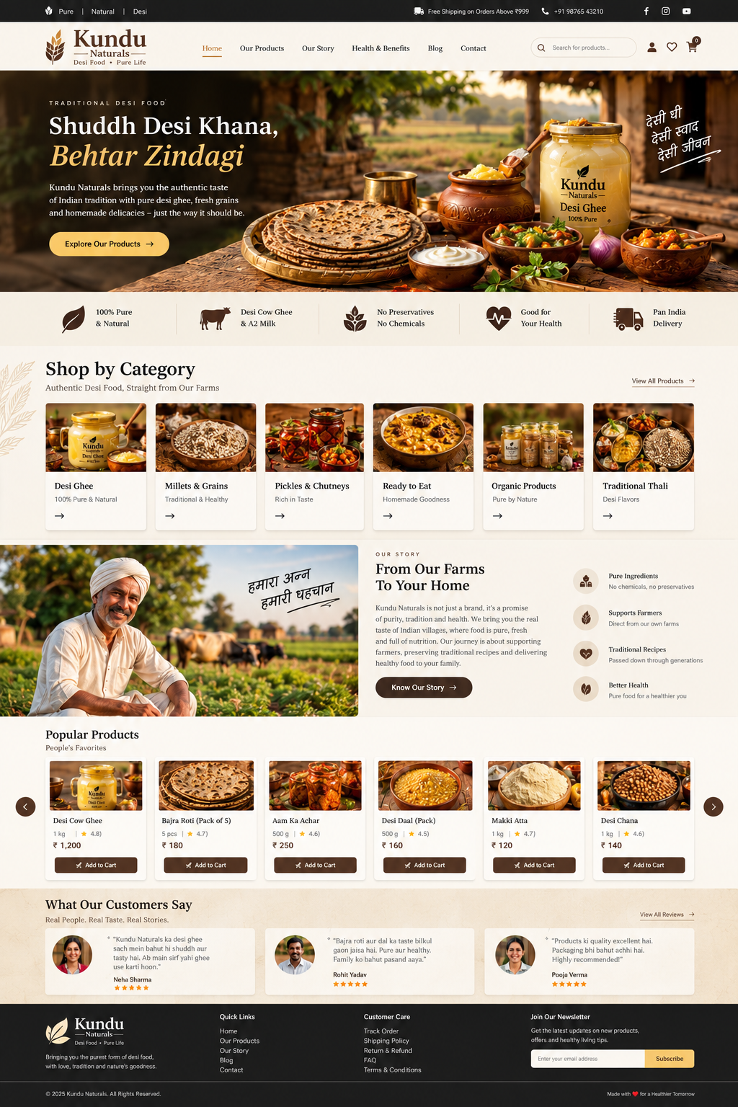

COPY THIS PROMPT INTO OPENCODE

KUNDU NATURALS — WEBSITE THEME & DESIGN MASTER PROMPT
Act as a senior UI/UX designer and frontend design specialist. Redesign the visual theme and interface of my existing Kundu Naturals website to closely match the reference screenshot embedded at the beginning of this document.
IMPORTANT: I only want the website's visual design system, color palette, layout, spacing, typography, component styling and overall theme to resemble the reference image. Do not generate, invent, or replace any product photographs or product content. I will upload my own genuine product photographs and enter my own product names, prices, descriptions and details later.

1. Visual direction
Follow the reference screenshot as closely as practical. The website should feel premium, professional, traditional Indian, warm, elegant, authentic and suitable for a desi food brand. Combine modern professional e-commerce design with traditional Indian food-brand aesthetics. Do not make it look like a generic corporate website, SaaS dashboard or green organic-food template.

2. Color palette
Use this consistent color system inspired by the reference:
- Warm Ivory: #F8F3E9
- Cream Background: #F2E7D5
- Soft Cream Card: #FFFCF6
- Deep Espresso Brown: #302018
- Dark Coffee Brown: #452A1D
- Antique Gold: #D6AD62
- Warm Golden Yellow: #F2C66D
- Terracotta Accent: #A94F2B
- Muted Beige Border: #DED0BC
- Primary Text: #241A14
- Secondary Text: #76675A
Strict color rules:
- Absolutely no green anywhere in the website theme.
- No green buttons, icons, backgrounds or gradients.
- No blue-and-white corporate theme, neon colors or excessive gradients.
- Avoid a flat, plain-white website.
- Use dark brown for navigation, buttons, footer and important elements.
- Use cream and ivory for main backgrounds.
- Use antique gold for highlights, hover states and primary actions.
- Use terracotta sparingly for traditional accents.
You may fine-tune these values to match the reference while preserving the same warm palette.

3. Header and navigation
Style a slim dark announcement bar above a cream main navigation bar. Place the existing logo on the left, navigation links in the center, and search/account/wishlist/cart icons on the right. Use subtle borders, consistent spacing, clean alignment, and professional hover and active states. Preserve my existing logo and working navigation where possible.

4. Hero section
Match the proportions and visual hierarchy of the reference hero section. I will supply my own hero photograph:
- Do not generate or insert food photography.
- If no hero image is available, use a neutral placeholder.
- Keep the image area ready for my own image.
- Support a full-width background image and an optional dark overlay for text readability.
- Place headline and description on the left, with an antique-gold primary button.
- Preserve generous spacing and strong contrast.

5. Category cards
Create reusable category cards with an image placeholder for my own uploads, editable title and optional description, a small arrow icon, cream backgrounds, fine beige borders, consistent image ratios, subtle shadows and restrained hover effects. Do not insert generated or unrelated images.

6. Product cards and grids
Create reusable product-card styling for my own products. Each card should support my image, product name, description, pack size, price, optional real rating, wishlist icon and add-to-cart button. Until my content is provided, use neutral image placeholders and clearly editable fields. Do not invent real prices, reviews, product claims or product photos.
Use cream/ivory cards, espresso-brown text, dark-brown buttons, antique-gold accents, subtle borders and shadows, consistent image proportions, and clean alignment.

7. Other sections
Apply the same theme to existing brand story, benefits, promotional banners, product collections, reviews, newsletter, contact section and footer. Preserve existing images and content already in my project. If an image is missing, use a neutral placeholder rather than generating a replacement. Keep components modular so I can add my own images and text later.

8. Typography and spacing
Use elegant serif headings, a clean sans-serif for body text, and legible Hindi typography. Suggested fonts: Playfair Display for headings, Inter for body text, and Noto Sans Devanagari for Hindi. Maintain a consistent type scale, line height, section spacing, card padding, button height, border radius and content width.

9. Backgrounds and effects
Use subtle warm textures only where appropriate, thin beige separators, gentle shadows, restrained gold highlights and smooth, understated transitions. Avoid excessive animation, heavy glassmorphism, bright gradients, toy-like rounded components and unnecessary decoration.

10. Responsive design
Make the theme work beautifully on desktop, laptop, tablet and mobile. Ensure responsive navigation, balanced product grids, proper image cropping, touch-friendly controls, readable typography and no horizontal overflow.

11. Work in my existing VS Code project
1. Inspect the existing project and identify its framework.
2. Review current pages, components, images, styles and functionality.
3. Preserve my existing product data, uploaded images, logo and working features.
4. Update the theme and styling to match the attached reference.
5. Reuse components and avoid unnecessary rewrites.
6. Use reusable CSS variables/theme tokens for colors, typography, spacing, borders, shadows and buttons.
7. Run the project and fix visual/build errors.

FINAL INSTRUCTION
The embedded screenshot is the visual design reference, not a source of product content. Match its overall theme, color palette, layout, typography, spacing, navigation, card styling and premium traditional Indian appearance. Do not copy its product photos or invent new ones. I will upload my own genuine product images and product information later.
Focus on making Kundu Naturals look like a premium, professional, traditional Indian desi-food brand using warm cream, espresso brown, antique gold and terracotta — with absolutely no green. Implement these visual changes directly in my existing VS Code project.

